Lab Assignment Machine Learning

Aditya Wakade

21 February 2018

Loading the data and marking incomes higher than 50,000

data <- read.csv('census data.csv')  
data$income.g50 <-rep(0, nrow(data))  
data$income.g50[data$income==" >50K"] <-1

finding summary

mod <-glm(income.g50 ~ education + age + sex + race,data=data[,!colnames(data)%in%"income"], family="binomial")  
summary(mod)

##   
## Call:  
## glm(formula = income.g50 ~ education + age + sex + race, family = "binomial",   
## data = data[, !colnames(data) %in% "income"])  
##   
## Deviance Residuals:   
## Min 1Q Median 3Q Max   
## -2.4997 -0.6802 -0.4460 -0.1114 2.8328   
##   
## Coefficients:  
## Estimate Std. Error z value Pr(>|z|)   
## (Intercept) -6.865618 0.504710 -13.603 < 2e-16 ***  
## education 11th 0.296538 0.327880 0.904 0.36578   
## education 12th 0.724955 0.386826 1.874 0.06092 .   
## education 1st-4th -0.180178 0.656420 -0.274 0.78371   
## education 5th-6th -1.065786 0.638832 -1.668 0.09525 .   
## education 7th-8th -0.055193 0.344602 -0.160 0.87275   
## education 9th -0.472650 0.422347 -1.119 0.26310   
## education Assoc-acdm 1.793180 0.276081 6.495 8.30e-11 ***  
## education Assoc-voc 1.806001 0.265792 6.795 1.08e-11 ***  
## education Bachelors 2.498991 0.246065 10.156 < 2e-16 ***  
## education Doctorate 3.465742 0.316322 10.956 < 2e-16 ***  
## education HS-grad 1.099579 0.244388 4.499 6.82e-06 ***  
## education Masters 2.910088 0.256902 11.328 < 2e-16 ***  
## education Preschool -10.727247 130.041047 -0.082 0.93426   
## education Prof-school 3.834590 0.308031 12.449 < 2e-16 ***  
## education Some-college 1.590668 0.246311 6.458 1.06e-10 ***  
## age 0.043369 0.002061 21.043 < 2e-16 ***  
## sex Male 1.291684 0.066444 19.440 < 2e-16 ***  
## race Asian-Pac-Islander 1.009867 0.457049 2.210 0.02714 *   
## race Black 1.119303 0.442857 2.527 0.01149 *   
## race Other 0.213828 0.654001 0.327 0.74370   
## race White 1.392564 0.431938 3.224 0.00126 **   
## ---  
## Signif. codes: 0 '***' 0.001 '**' 0.01 '*' 0.05 '.' 0.1 ' ' 1  
##   
## (Dispersion parameter for binomial family taken to be 1)  
##   
## Null deviance: 11151.2 on 9999 degrees of freedom  
## Residual deviance: 8900.2 on 9978 degrees of freedom  
## AIC: 8944.2  
##   
## Number of Fisher Scoring iterations: 12

The exponent values for log values of masters dcotral prof-colg From the summary we can interpret that having a prof-school, doctrate, masters, bachelors degree gives higher odds of having a salary more than 50K. At the same time, the odds of having a salary less than 50K increase for only preschool education. All these are the results having *** significance codes that is they are more reliable.

Age significantly does not provide a lot of oddsin the salary, which tells us that it does not really play as a decider.

Race value being white provides higher and more significant odds ratio of the salary being more than 50K.

Sex being male also significantly affects the salary being more than 50K

1. Exploring RelationshipsII:Plot age by the outcome and the observed predicted probabilities. Why are the predicted probabilities so variable?

x <-data$age  
plot(data$income.g50~x, col="blue")  
fits <-fitted(mod)  
points(x, fits, pch = 4 , cex=0.3)  
abline(0.5, 0)

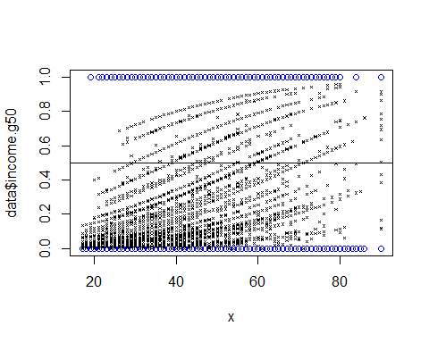

The predicted probabilities are so variable because age is not a good decider. People from all ages are account for salaries greater than 50K and go ahead to be more than 50K.

1. Explore some cutoffs for the probabilities:Tabulate the outcome with a cutoff of 0.25, 0.5, and 0.75. Which has the lowest percent error?

tab <-table(data$income.g50, fits>=0.5)  
(tab[1,2]+tab[2,1])/sum(tab)

## [1] 0.2061

tab <-table(data$income.g50, fits>=0.25)  
(tab[1,2]+tab[2,1])/sum(tab)

## [1] 0.2662

tab <-table(data$income.g50, fits>=0.75)  
(tab[1,2]+tab[2,1])/sum(tab)

## [1] 0.2307

Tab with 0.5 as cut off has the lowest percentage error.

1. Examine this model.a. Plot the ROC curve and calculate the AUC for this model.

library(AUC)

## AUC 0.3.0

## Type AUCNews() to see the change log and ?AUC to get an overview.

y <-factor(data$income.g50)  
rr <-roc(fits, y)  
plot(rr)

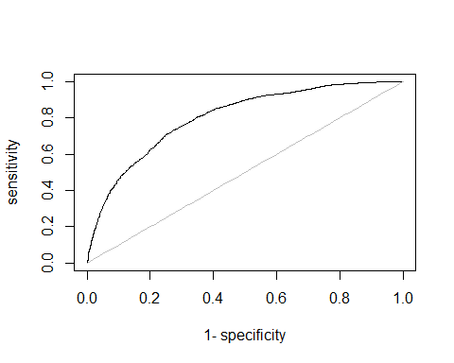

auc(rr)

## [1] 0.8021133

By plotting the true positives against the false positive we come to know that area under the curve is about 80% for this fitted model.

1. Let’s formulate another model. a.Fit a model with all covariates (except “income”!). Do you see the same patterns for level of schooling?

mod1 <-glm(income.g50~., data=data[,!colnames(data)%in%c("income")], family="binomial")

## Warning: glm.fit: fitted probabilities numerically 0 or 1 occurred

summary(mod1)

##   
## Call:  
## glm(formula = income.g50 ~ ., family = "binomial", data = data[,   
## !colnames(data) %in% c("income")])  
##   
## Deviance Residuals:   
## Min 1Q Median 3Q Max   
## -2.6128 -0.5605 -0.2026 -0.0001 3.2983   
##   
## Coefficients: (2 not defined because of singularities)  
## Estimate Std. Error z value  
## (Intercept) -9.931e+00 7.766e-01 -12.787  
## age 2.801e-02 2.783e-03 10.062  
## work.class Federal-gov 1.071e+00 2.656e-01 4.032  
## work.class Local-gov 1.906e-01 2.418e-01 0.789  
## work.class Never-worked -1.359e+01 9.580e+02 -0.014  
## work.class Private 3.800e-01 2.144e-01 1.772  
## work.class Self-emp-inc 8.081e-01 2.563e-01 3.153  
## work.class Self-emp-not-inc 2.786e-01 2.334e-01 1.194  
## work.class State-gov 2.782e-01 2.620e-01 1.062  
## work.class Without-pay -1.459e+01 8.999e+02 -0.016  
## final.weight 1.082e-06 2.937e-07 3.684  
## education 11th 5.089e-01 3.490e-01 1.458  
## education 12th 6.785e-01 4.153e-01 1.634  
## education 1st-4th 2.756e-01 7.168e-01 0.384  
## education 5th-6th -7.479e-01 6.666e-01 -1.122  
## education 7th-8th 1.145e-01 3.636e-01 0.315  
## education 9th -2.324e-01 4.387e-01 -0.530  
## education Assoc-acdm 1.466e+00 3.018e-01 4.857  
## education Assoc-voc 1.473e+00 2.868e-01 5.136  
## education Bachelors 2.092e+00 2.668e-01 7.841  
## education Doctorate 2.892e+00 3.582e-01 8.075  
## education HS-grad 9.690e-01 2.599e-01 3.728  
## education Masters 2.429e+00 2.838e-01 8.558  
## education Preschool -1.309e+01 4.975e+02 -0.026  
## education Prof-school 3.346e+00 3.489e-01 9.593  
## education Some-college 1.412e+00 2.637e-01 5.356  
## years.school NA NA NA  
## marital.status Married-AF-spouse 2.779e+00 9.247e-01 3.005  
## marital.status Married-civ-spouse 2.571e+00 4.121e-01 6.240  
## marital.status Married-spouse-absent 1.422e-01 3.693e-01 0.385  
## marital.status Never-married -5.452e-01 1.435e-01 -3.799  
## marital.status Separated -2.253e-01 2.789e-01 -0.808  
## marital.status Widowed 2.295e-01 2.378e-01 0.965  
## occupation Adm-clerical 1.308e-01 1.719e-01 0.761  
## occupation Armed-Forces 5.030e-01 2.025e+00 0.248  
## occupation Craft-repair 3.629e-01 1.471e-01 2.468  
## occupation Exec-managerial 9.648e-01 1.510e-01 6.389  
## occupation Farming-fishing -8.811e-01 2.372e-01 -3.714  
## occupation Handlers-cleaners -5.332e-01 2.531e-01 -2.107  
## occupation Machine-op-inspct -4.981e-02 1.885e-01 -0.264  
## occupation Other-service -7.228e-01 2.209e-01 -3.272  
## occupation Priv-house-serv -1.482e+01 3.074e+02 -0.048  
## occupation Prof-specialty 8.118e-01 1.628e-01 4.986  
## occupation Protective-serv 7.941e-01 2.272e-01 3.495  
## occupation Sales 5.718e-01 1.565e-01 3.655  
## occupation Tech-support 8.180e-01 2.111e-01 3.874  
## occupation Transport-moving NA NA NA  
## relationship Not-in-family 1.066e+00 4.082e-01 2.612  
## relationship Other-relative 9.728e-02 3.960e-01 0.246  
## relationship Own-child -1.158e-01 3.979e-01 -0.291  
## relationship Unmarried 8.553e-01 4.379e-01 1.953  
## relationship Wife 1.414e+00 1.734e-01 8.153  
## race Asian-Pac-Islander 1.297e+00 5.309e-01 2.443  
## race Black 1.582e+00 4.790e-01 3.303  
## race Other 6.241e-01 7.072e-01 0.882  
## race White 1.477e+00 4.642e-01 3.182  
## sex Male 8.170e-01 1.294e-01 6.314  
## hours.per.week 2.709e-02 2.802e-03 9.667  
## native.country Cambodia -1.570e+01 2.400e+03 -0.007  
## native.country Canada -5.204e-02 5.318e-01 -0.098  
## native.country China -6.827e-01 7.817e-01 -0.873  
## native.country Columbia -1.466e+01 5.030e+02 -0.029  
## native.country Cuba 6.734e-02 6.530e-01 0.103  
## native.country Dominican-Republic 4.164e-01 1.179e+00 0.353  
## native.country Ecuador -1.097e+00 1.265e+00 -0.867  
## native.country El-Salvador -1.070e+00 1.101e+00 -0.972  
## native.country England -8.452e-02 5.520e-01 -0.153  
## native.country France -1.111e-01 9.069e-01 -0.122  
## native.country Germany -8.578e-02 4.975e-01 -0.172  
## native.country Greece -2.564e-01 1.251e+00 -0.205  
## native.country Guatemala -1.296e+01 4.019e+02 -0.032  
## native.country Haiti 1.956e-01 1.228e+00 0.159  
## native.country Holand-Netherlands -1.142e+01 2.400e+03 -0.005  
## native.country Honduras -1.226e+01 1.661e+03 -0.007  
## native.country Hong -9.191e-01 1.279e+00 -0.719  
## native.country Hungary -6.953e-01 1.206e+00 -0.576  
## native.country India -7.849e-01 5.551e-01 -1.414  
## native.country Iran -7.106e-01 6.707e-01 -1.059  
## native.country Ireland 2.469e+00 1.112e+00 2.220  
## native.country Italy 3.133e-01 5.871e-01 0.534  
## native.country Jamaica -1.495e+00 1.163e+00 -1.285  
## native.country Japan 5.607e-01 7.278e-01 0.770  
## native.country Laos -1.290e+01 1.278e+03 -0.010  
## native.country Mexico -5.061e-01 4.300e-01 -1.177  
## native.country Nicaragua -1.277e+01 5.948e+02 -0.021  
## native.country Outlying-US(Guam-USVI-etc) -1.372e+01 1.639e+03 -0.008  
## native.country Peru -6.137e-01 1.185e+00 -0.518  
## native.country Philippines 4.936e-01 4.786e-01 1.031  
## native.country Poland -6.022e-01 7.578e-01 -0.795  
## native.country Portugal -5.827e-01 8.321e-01 -0.700  
## native.country Puerto-Rico -2.545e-01 8.308e-01 -0.306  
## native.country Scotland 1.799e+00 2.329e+00 0.772  
## native.country South 1.198e+00 7.514e-01 1.594  
## native.country Taiwan 8.449e-01 8.614e-01 0.981  
## native.country Thailand -1.556e+01 7.463e+02 -0.021  
## native.country Trinadad&Tobago -1.489e+01 6.211e+02 -0.024  
## native.country United-States 9.913e-02 2.352e-01 0.422  
## native.country Vietnam -1.438e+01 4.332e+02 -0.033  
## native.country Yugoslavia 9.149e-01 1.152e+00 0.794  
## Pr(>|z|)   
## (Intercept) < 2e-16 ***  
## age < 2e-16 ***  
## work.class Federal-gov 5.53e-05 ***  
## work.class Local-gov 0.430391   
## work.class Never-worked 0.988680   
## work.class Private 0.076345 .   
## work.class Self-emp-inc 0.001614 **   
## work.class Self-emp-not-inc 0.232498   
## work.class State-gov 0.288261   
## work.class Without-pay 0.987064   
## final.weight 0.000229 ***  
## education 11th 0.144783   
## education 12th 0.102305   
## education 1st-4th 0.700626   
## education 5th-6th 0.261868   
## education 7th-8th 0.752799   
## education 9th 0.596310   
## education Assoc-acdm 1.19e-06 ***  
## education Assoc-voc 2.81e-07 ***  
## education Bachelors 4.48e-15 ***  
## education Doctorate 6.76e-16 ***  
## education HS-grad 0.000193 ***  
## education Masters < 2e-16 ***  
## education Preschool 0.979003   
## education Prof-school < 2e-16 ***  
## education Some-college 8.50e-08 ***  
## years.school NA   
## marital.status Married-AF-spouse 0.002656 **   
## marital.status Married-civ-spouse 4.39e-10 ***  
## marital.status Married-spouse-absent 0.700213   
## marital.status Never-married 0.000145 ***  
## marital.status Separated 0.419369   
## marital.status Widowed 0.334629   
## occupation Adm-clerical 0.446735   
## occupation Armed-Forces 0.803801   
## occupation Craft-repair 0.013603 *   
## occupation Exec-managerial 1.67e-10 ***  
## occupation Farming-fishing 0.000204 ***  
## occupation Handlers-cleaners 0.035141 *   
## occupation Machine-op-inspct 0.791561   
## occupation Other-service 0.001069 **   
## occupation Priv-house-serv 0.961563   
## occupation Prof-specialty 6.16e-07 ***  
## occupation Protective-serv 0.000474 ***  
## occupation Sales 0.000257 ***  
## occupation Tech-support 0.000107 ***  
## occupation Transport-moving NA   
## relationship Not-in-family 0.009007 **   
## relationship Other-relative 0.805962   
## relationship Own-child 0.770953   
## relationship Unmarried 0.050796 .   
## relationship Wife 3.55e-16 ***  
## race Asian-Pac-Islander 0.014551 *   
## race Black 0.000956 ***  
## race Other 0.377522   
## race White 0.001464 **   
## sex Male 2.71e-10 ***  
## hours.per.week < 2e-16 ***  
## native.country Cambodia 0.994780   
## native.country Canada 0.922047   
## native.country China 0.382520   
## native.country Columbia 0.976742   
## native.country Cuba 0.917856   
## native.country Dominican-Republic 0.723996   
## native.country Ecuador 0.385726   
## native.country El-Salvador 0.331226   
## native.country England 0.878306   
## native.country France 0.902526   
## native.country Germany 0.863105   
## native.country Greece 0.837672   
## native.country Guatemala 0.974279   
## native.country Haiti 0.873493   
## native.country Holand-Netherlands 0.996204   
## native.country Honduras 0.994109   
## native.country Hong 0.472426   
## native.country Hungary 0.564316   
## native.country India 0.157345   
## native.country Iran 0.289381   
## native.country Ireland 0.026418 *   
## native.country Italy 0.593623   
## native.country Jamaica 0.198734   
## native.country Japan 0.441016   
## native.country Laos 0.991945   
## native.country Mexico 0.239145   
## native.country Nicaragua 0.982877   
## native.country Outlying-US(Guam-USVI-etc) 0.993321   
## native.country Peru 0.604662   
## native.country Philippines 0.302354   
## native.country Poland 0.426827   
## native.country Portugal 0.483797   
## native.country Puerto-Rico 0.759396   
## native.country Scotland 0.439892   
## native.country South 0.110847   
## native.country Taiwan 0.326663   
## native.country Thailand 0.983363   
## native.country Trinadad&Tobago 0.980871   
## native.country United-States 0.673385   
## native.country Vietnam 0.973523   
## native.country Yugoslavia 0.426912   
## ---  
## Signif. codes: 0 '***' 0.001 '**' 0.01 '*' 0.05 '.' 0.1 ' ' 1  
##   
## (Dispersion parameter for binomial family taken to be 1)  
##   
## Null deviance: 11151.2 on 9999 degrees of freedom  
## Residual deviance: 6997.9 on 9903 degrees of freedom  
## AIC: 7191.9  
##   
## Number of Fisher Scoring iterations: 15

x1 <-data$age  
plot(data$income.g50~x1, col="blue")  
fits1 <-fitted(mod1)  
points(x1, fits1, pch = 4 , cex=0.3)  
abline(0.5, 0)

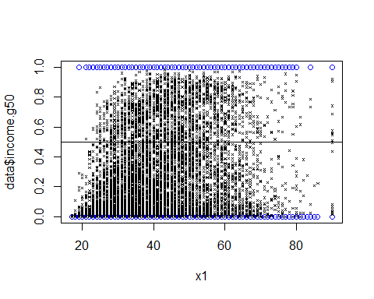 The probability values provided by the age variable are much less variable now. It clearly denotes how the probabilities of people between 35-55 are more for having a higherincome than 50K.

c.Calculate thepercent error as before for cutoffs 0.25, 0.5, 0.75. Which cutoff has the lowest percent error? Does this model perform better than the other model?

tab <-table(data$income.g50, fits1>=0.5)  
(tab[1,2]+tab[2,1])/sum(tab)

## [1] 0.1659

tab <-table(data$income.g50, fits1>=0.25)  
(tab[1,2]+tab[2,1])/sum(tab)

## [1] 0.2071

tab <-table(data$income.g50, fits1>=0.75)  
(tab[1,2]+tab[2,1])/sum(tab)

## [1] 0.1943

The error is least for 0.5 and much less than the previous model.

1. Plot the ROC and calculate the AUC. Again, does this model outperform the other model?

y <-factor(data$income.g50)  
rr <-roc(fits1, y)  
plot(rr)

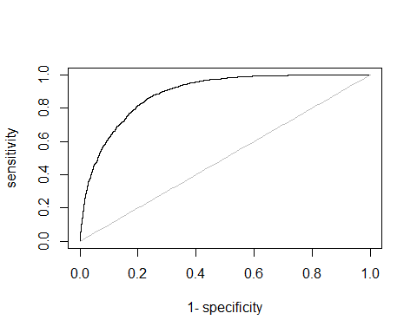

auc(rr)

## [1] 0.8893198

AUC IS 0.889 which is much better than the previous model